USE bankloans;

SELECT * FROM loan_details;

UPDATE loan_details

SET issue_date=str_to_date(issue_date,"%d-%m-%Y");

ALTER TABLE loan_details

MODIFY issue_date date;

**-- TOTAL LOAN APPLICATIONS**

SELECT COUNT(id) Total_Loan_Applications FROM loan_details;

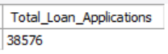

**-- MTD LOAN APPLICATIONS**

SELECT COUNT(id) MTD_Loan_Applications FROM loan_details

WHERE MONTH(issue_date)=12 AND YEAR(issue_date)=2021;



**-- PMTD LOAN APPLICATIONS**

SELECT COUNT(id) PMTD_Loan_Applications FROM loan_details

WHERE MONTH(issue_date)=11 AND YEAR(issue_date)=2021;



-- **TOTAL FUNDED AMOUNT**

SELECT SUM(loan_amount) Total_Funded_Amount FROM loan_details;

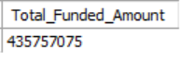

**-- MTD FUNDED AMOUNT**

SELECT SUM(loan_amount) MTD_Funded_Amount FROM loan_details

WHERE MONTH(issue_date)=12 AND YEAR(issue_date)=2021;



**-- PMTD FUNDED AMOUNT**

SELECT SUM(loan_amount) PMTD_Funded_Amount FROM loan_details

WHERE MONTH(issue_date)=11 AND YEAR(issue_date)=2021;



**-- TOTAL AMOUNT RECEIVED**

SELECT SUM(total_payment) Total_Amount_Received FROM loan_details;



**-- MTD AMOUNT RECEIVED**

SELECT SUM(total_payment) MTD_Amount_Received FROM loan_details

WHERE MONTH(issue_date)=12 AND YEAR(issue_date)=2021;

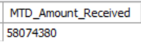

**-- PMTD AMOUNT RECEIVED**

SELECT SUM(total_payment) PMTD_Amount_Received FROM loan_details

WHERE MONTH(issue_date)=11 AND YEAR(issue_date)=2021;



**-- AVERAGE INTEREST RATE**

SELECT ROUND(AVG(int_rate)*100,2) Avg_Interest_rate FROM loan_details;

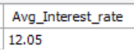

**-- MTD AVERAGE INTEREST RATE**

SELECT ROUND(AVG(int_rate)*100,2) MTD_Avg_Interest_rate FROM loan_details

WHERE MONTH(issue_date)=12 AND YEAR(issue_date)=2021;



**-- PMTD AVERAGE INTEREST RATE**

SELECT ROUND(AVG(int_rate)*100,2) PMTD_Avg_Interest_rate FROM loan_details

WHERE MONTH(issue_date)=11 AND YEAR(issue_date)=2021;

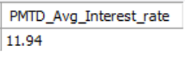

**-- AVERAGE DTI RATE**

SELECT ROUND(AVG(dti)*100,2) Avg_DTI FROM loan_details;



**-- MTD DTI RATE**

SELECT ROUND(AVG(dti)*100,2) MTD_Avg_DTI FROM loan_details

WHERE MONTH(issue_date)=12 AND YEAR(issue_date)=2021;



**-- PMTD DTI RATE**

SELECT ROUND(AVG(dti)*100,2) PMTD_Avg_DTI FROM loan_details

WHERE MONTH(issue_date)=11 AND YEAR(issue_date)=2021;

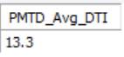

**-- GOOD LOAN APPLICATION PERCENTAGE**

SELECT

(COUNT(CASE WHEN loan_status="Fully Paid" OR loan_status="Current" THEN id END)*100)

/

COUNT(id) Good_loan_Application_Percentage

FROM loan_details;

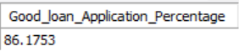

**-- GOOD LOAN APPLICATIONS**

SELECT COUNT(id) Good_Loan_Applications

FROM loan_details

WHERE loan_status="Fully Paid" OR loan_status="Current";

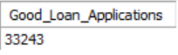

**-- GOOD LOAN FUNDED AMOUNT**

SELECT SUM(loan_amount) Good_Loan_Funded_Amount

FROM loan_details

WHERE loan_status="Fully Paid" OR loan_status="Current";



**-- GOOD LOAN TOTAL RECEIVED AMOUNT**

SELECT SUM(total_payment) Good_Loan_Received_Amount

FROM loan_details

WHERE loan_status="Fully Paid" OR loan_status="Current";



**-- BAD LOAN APPLICATION PERCENTAGE**

SELECT

(COUNT(CASE WHEN loan_status="Charged Off"THEN id END)*100)

/

COUNT(id) Bad_loan_Application_Percentage

FROM loan_details;

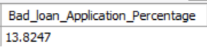

**-- BAD LOAN APPLICATIONS**

SELECT COUNT(id) Bad_Loan_Applications

FROM loan_details

WHERE loan_status="Charged Off";



**-- BAD LOAN FUNDED AMOUNT**

SELECT SUM(loan_amount) Bad_Loan_Funded_Amount

FROM loan_details

WHERE loan_status="Charged Off";



**-- BAD LOAN TOTAL RECEIVED AMOUNT**

SELECT SUM(total_payment) Bad_Loan_Received_Amount

FROM loan_details

WHERE loan_status="Charged Off";

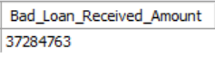

**-- LOAN STATUS GRID VIEW**

SELECT

loan_status,

COUNT(id) AS Total_Loan_Applications,

SUM(total_payment) AS Total_Amount_Received,

SUM(loan_amount) AS Total_Funded_Amount,

AVG(int_rate * 100) AS Interest_Rate,

AVG(dti * 100) AS DTI

FROM loan_details

GROUP BY loan_status;

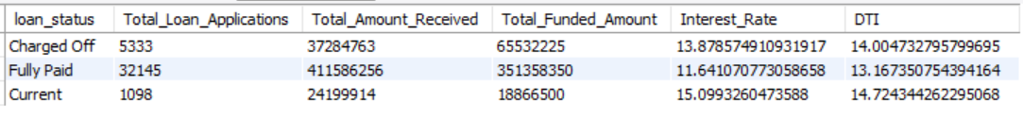

SELECT loan_status,

SUM(total_payment) AS MTD_Amount_Received,

SUM(loan_amount) AS MTD_Funded_Amount

FROM loan_details

WHERE MONTH(issue_date)=12 AND YEAR(issue_date)=2021

GROUP BY loan_status;

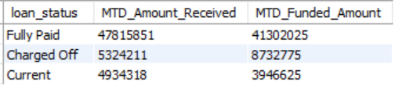

**-- MONTHLY TREND BY ISSUE DATE**

SELECT MONTH(issue_date) AS Month_Munber,

MONTHNAME(issue_date) AS Month_name,

COUNT(id) AS Total_Loan_Applications,

SUM(loan_amount) AS Total_Funded_Amount,

SUM(total_payment) AS Total_Amount_Received

FROM loan_details

GROUP BY MONTH(issue_date), MONTHNAME(issue_date)

ORDER BY MONTH(issue_date);

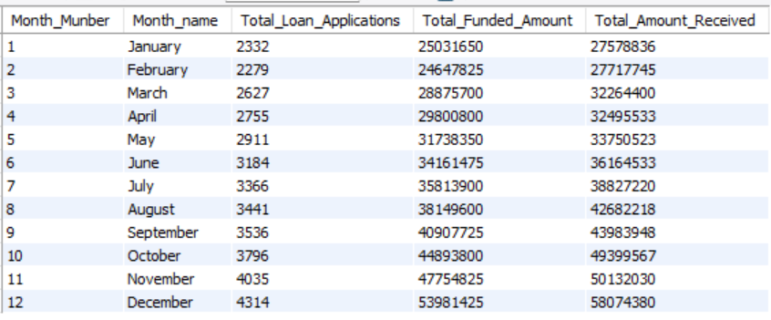

**-- EMPLOYEE LENGTH**

SELECT emp_length,

COUNT(id) AS Total_Loan_Applications,

SUM(loan_amount) AS Total_Funded_Amount,

SUM(total_payment) AS Total_Amount_Received

FROM loan_details

GROUP BY emp_length

ORDER BY emp_length;

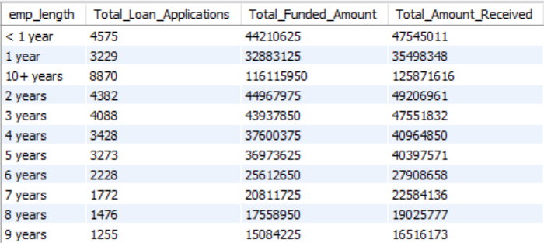

**-- REGION**

SELECT address_state,

COUNT(id) AS Total_Loan_Applications,

SUM(loan_amount) AS Total_Funded_Amount,

SUM(total_payment) AS Total_Amount_Received

FROM loan_details

GROUP BY address_state

ORDER BY address_state;

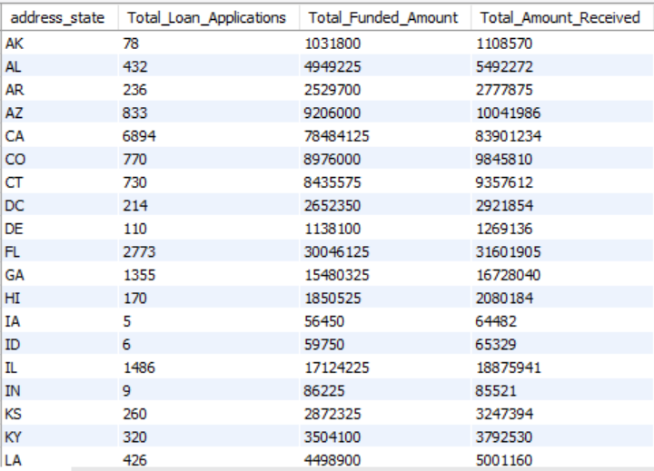

**-- TERM**

SELECT term,

COUNT(id) AS Total_Loan_Applications,

SUM(loan_amount) AS Total_Funded_Amount,

SUM(total_payment) AS Total_Amount_Received

FROM loan_details

GROUP BY term

ORDER BY term;

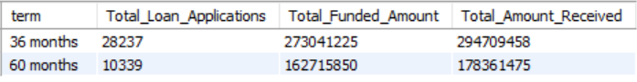

**-- PURPOSE**

SELECT purpose,

COUNT(id) AS Total_Loan_Applications,

SUM(loan_amount) AS Total_Funded_Amount,

SUM(total_payment) AS Total_Amount_Received

FROM loan_details

GROUP BY purpose

ORDER BY purpose;

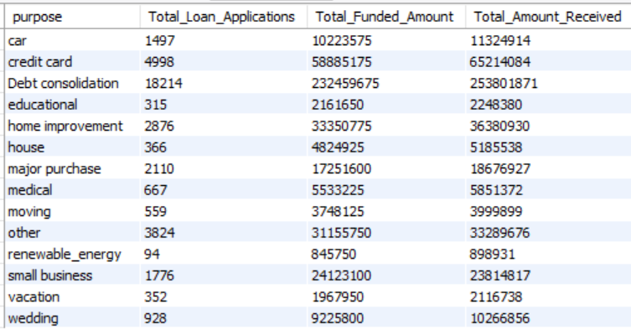

**-- HOME OWNERSHIP**

SELECT home_ownership,

COUNT(id) AS Total_Loan_Applications,

SUM(loan_amount) AS Total_Funded_Amount,

SUM(total_payment) AS Total_Amount_Received

FROM loan_details

GROUP BY home_ownership

ORDER BY home_ownership;

